1. Introduction - the Coroner’s Court

The sections in this chapter are:
- What does the coroner’s court do?
- Flow chart of the process
- How is the coroner’s court different from other courts?
- Court structure - overview
- A day in the coroner’s court
- Jurisdiction of the coroner’s court

What does the coroner’s court do?
The Coronial Division of the Magistrates Court (or the ‘coroner’s court’) investigates certain deaths, fires and explosions by collecting and examining evidence and making findings. There are a lot of people involved in this process, most importantly, the families and friends of people who have died suddenly. Often the coronial process is an emotional one and friends, families, employees and professionals and others touched by a death need many levels of help and support.

The purposes and objectives of the coroner’s court are to:
- identify deceased persons
- find out how and why a person died
- establish the cause and origin of fires and explosions
- learn from experience to help prevent similar deaths occurring
- improve our systems of public health and safety
- further the administration of justice
- allay suspicions and fears
- hold public agencies to account for deaths in the State’s custody or care; such as police, prisons and health services
- investigate in public where appropriate
- reinforce the rule of law in democratic societies
- provide quality assurance in the death investigation process.

Coronial investigations involve a delicate balance between the rights of the public and the rights of the individual. It is important to protect the privacy of individuals, especially the deceased who can no longer speak for themselves. Families have a right to privacy and a period of grief, but often they feel the need to know what happened to their loved one. The promotion of public health and safety is amongst the most important roles for the coroner’s court and sometimes the knowledge gained from a detailed investigation of a particular death can assist greatly in preventing deaths. In cases involving public agencies, transparency and accountability may be aided by disclosing information to the public in general. Impartial pursuit of the truth is paramount, but coroners also aim to be sensitive to the bereaved. In all aspects of their investigations, coroners strive to find balance.

Flow chart of the process
Figure 1 is a flow chart of the most common way in which a coronial matter proceeds following a recent death.
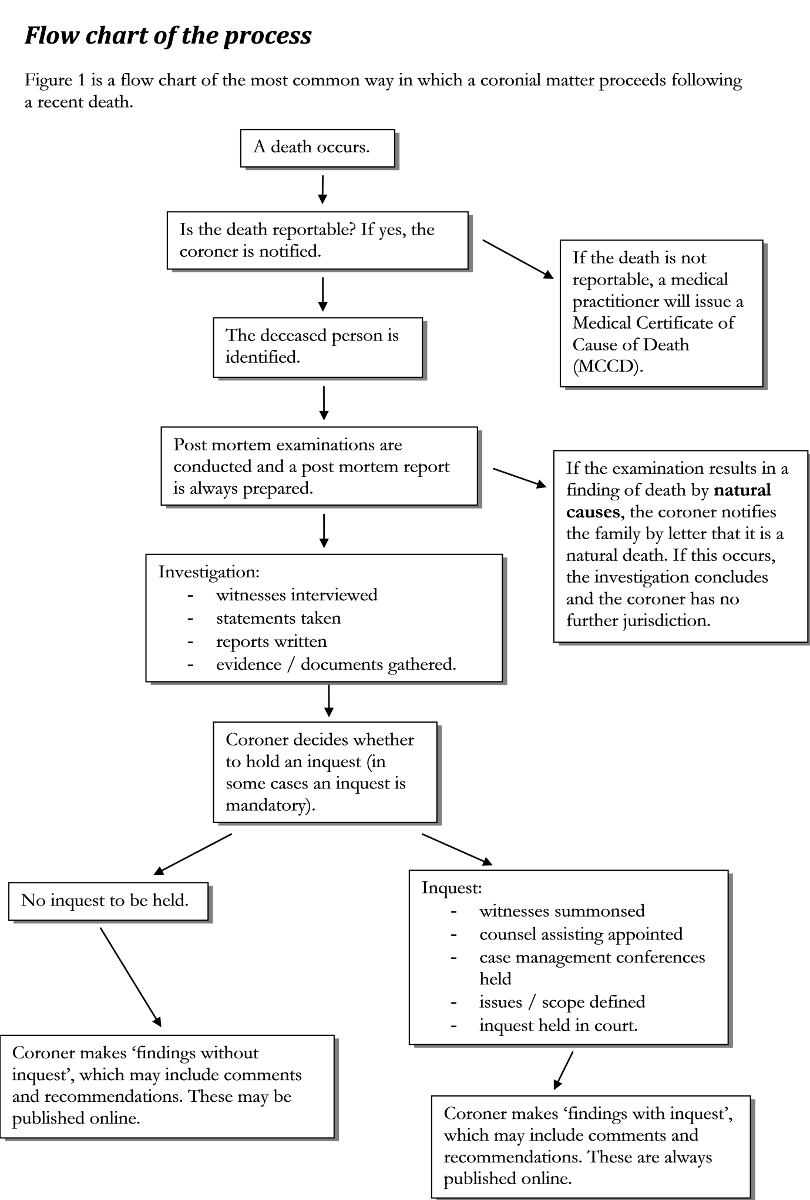

Figure 1 is a flow chart explaining a coronial investigation into a recent death. When a death occurs, either a doctor will write a Medical Certificate of Cause of Death or the death will be reported to the coroner. If the death is reported, a pathologist conducts post mortem examinations on the deceased person. If the death remains in the category of reportable deaths after this, the coroner will conduct a full investigation. If the legislation mandates it, or the coroner believes it is necessary, the coroner will hold an inquest. After the inquest or investigation, the coroner will write “findings” which may be published on the Magistrates Court web site.

How is the coroner’s court different from other courts?
The coroner’s court is generally inquisitorial, with few adversarial elements
- Most courts are “adversarial” in nature; this means that there are two opposing sides (such as prosecution and defence). Both sides argue that the judge should accept their own case.
- In an “inquisitorial” court, there are no sides: there is simply a search for the truth in which all parties collaborate. Each party may still wish to emphasise certain facts over others. Judges in inquisitorial courts do not rely on others to give the information to them; rather they investigate actively and find things out for themselves.

The rules of evidence do not apply
- The Coroners Act 1995 (‘the Act’), specifies in section 51 that the rules of evidence do not apply to coronial proceedings. Instead, coroners may inform themselves in any manner the coroner reasonably thinks fit.
- This flexibility allows coroners to take into account materials that would not be admissible in a criminal trial, such as hearsay and non-expert opinion evidence.
- Relevance is still paramount in coronial matters: the relevant issues define the scope of the investigation (and of the inquest, if one is held).
- Enquiries made by the coroner must be relevant to the manner and cause of death; therefore, all parties are prevented from pursuing causation to its extreme (refer to ‘Key Elements in the Process: Inquests – Causation, scope and relevance’).

The common law has less effect
- Section 4 of the Act states that ‘a rule of the common law that, immediately before the commencement of this section, conferred a power or imposed a duty on a coroner or a coroner’s court ceases to have effect’.
- This provision removes the common law jurisdiction of the coroner’s court.
- It is most likely that ‘duties imposed on a coroner’ are procedural duties. A similar provision in the Coroners Act 2003 (Qld) expressly states as examples that coroners are not required to view a body or sit with a jury.
- Coroners remain bound by the authorities and judicial pronouncements of courts in interpreting the legislation.

The coroner’s court is neither criminal nor civil in nature
- A coronial inquest is an inquiry not a trial. Coroners are concerned with fact-finding, not determining guilt and delivering punishment.
- Coroners are not permitted to include in their findings a statement that a person is, or may be, guilty of committing an offence (Act ss 28(4) & 45(3)).
- Coronial proceedings are not criminal or civil in nature, but they may open the way for proceedings of either type.
- Criminal proceedings may result through referral of the case to the Attorney-General and the Attorney-General / Director of Public Prosecutions preferring charges.
- Civil proceedings may result through the disclosure of evidence that potentially supports the argument that a person or entity was negligent or responsible in some way for the death, fire or explosion.
- There may also be repercussions as to internal disciplinary proceedings, tribunals, commissions and similar.
- It is important that practitioners do not discount the consequences that coronial proceedings may have for their clients or treat an inquest as a mere precursor to future court proceedings.

The civil standard of proof applies
- The coroner must establish facts on the balance of probabilities.
- The standard expressed in the matter of Briginshaw v Briginshaw (1938) 60 CLR 336 at 362 is also relevant where a serious allegation is made, which it is necessary to determine, and the determination of that allegation will (or could) reflect adversely on a person:

‘…reasonable satisfaction is not a state of mind that is attained or established independently of the nature and consequence of the fact or facts to be proved. The seriousness of an allegation made, the inherent unlikelihood of an occurrence of a given description, or the gravity of the consequences flowing from a particular finding are considerations which must affect the answer to the question whether the issue has been proved to the reasonable satisfaction of the tribunal. In such matters ‘reasonable satisfaction’ should not be produced by inexact proofs, indefinite testimony, or indirect inferences. Everyone must feel that, when, for instance, the issue is on which of two dates an admitted occurrence took place, a satisfactory conclusion may be reached on materials of a kind that would not satisfy any sound and prudent judgment if the question was whether some act had been done involving grave moral delinquency.’

The focus can be on the system, the individual or both
- Unlike in criminal proceedings, some coronial investigations will focus on the acts of individuals, where others will focus on systemic issues.
- Many coronial investigations into deaths involve mistakes and accidents by professionals, rather than deliberate acts of malice.
- In such situations, coroners realise that:
  - mistakes and accidents are part of the execution of professional duties
  - good people make mistakes
  - most mistakes do not have negative consequences.
- When the coroner makes recommendations in these matters that are aimed at prevention, there is often less focus upon individual blame and error. The accidents and mistakes of individuals are often the least controllable aspects of a sequence of events.
- A systemic focus enables recommendations that anticipate, compensate for, detect, correct and prevent the mistakes that can lead to tragic events.
- These coronial matters involve learning lessons from systemic errors and creating environments in which those errors, on average:
  - are less likely to occur
  - will have less severe consequences if they do occur
  - are more likely to be detected and
  - can be more easily corrected.
- The criminal and civil aspects of the legal system are ‘blame-based’ and it can be challenging for legal practitioners to change their focus from the criminal or civil responsibility of individuals.

Court structure - overview
Legislation
The main framework for the coroner’s court is found in the following Tasmanian legislation:

- Coroners Act 1995 (Tas), hereafter referred to as ‘the Act’. All references to ‘sections’ in this document refer to the Act unless otherwise stated. The Act establishes the Coronial Division of the Magistrates Court and requires the reporting of certain deaths, sets out the procedures for investigations and inquests by coroners into deaths, fires and explosions, and provides for related matters.
- Coroners Rules 2006 (Tas), hereafter referred to as ‘the Rules’. All references to ‘rules’ in this document refer to the Rules unless otherwise stated. The Rules provide administrative information, including the form of various applications and directions, and procedures for investigation and inquests.
- Coroners (fees, expenses and allowances) Regulations 2016 (Tas). The Regulations contain the relevant fees schedules that apply to the Coronial Division.

For more information on other legislation that affects the coroner’s court, refer to ‘Other: Legislation’.

Coroners
Coroners investigate sudden deaths, and fires and explosions. Most coroners are magistrates and they perform functions similar to the head of a tribunal. They investigate in order to gather as much information as they can and then they make “findings”, which are contained in a written document. Coronial investigations are all about fact-finding; the coroner cannot punish people. If the coroner holds an inquest (a public court hearing), relevant witnesses will be required (usually by summons) to attend and give evidence.

An important role of the coroner is to make recommendations. When someone dies unexpectedly, the coroner can investigate how they died and recommend changes to save other lives. In this way, coroners administer justice and protect the health and safety of the public.

Coroners’ office
The business of the coroner’s court is conducted from the coroners’ office where all the staff work, gathering information and managing files. There are coroners’ offices in Hobart and Launceston, situated within the Magistrates Court buildings. If you have any questions about the coronial process, or about a particular matter, you can contact the relevant office between 9am and 5pm on weekdays. The offices are closed on public holidays.

You are able to phone, email, write or come in to the office, whichever you prefer. The coroner’s court also has a web site with relevant information and this Handbook covers many areas of coronial practice.

You can find the contact details here: ‘Other: How to contact the coroner’s court’.

Magistrates Court
The coroner’s court is a division of the Magistrates Court of Tasmania. Coroners hold inquests in the Magistrates Court in Hobart, Launceston, Burnie and Devonport. Generally, larger courtrooms are preferred for coronial inquests to allow for the additional legal practitioners and members of the public who attend.

The Magistrates Court is fully wheelchair accessible and is committed to providing equal access to justice for all people.

For more information about the layout of courtrooms, refer to ‘Key Elements in the Process: Court Proceedings – general information’.
For more information on extra assistance that the court can provide for those with diverse needs, refer to ‘A Guide for Families and Friends: Who can help? – If you need extra assistance’.

Police
All police officers are designated ‘coroners’ officers’ under the Act (s 16(2)). When an unexpected death, a fire or an explosion occurs, police are generally the first on the scene. It is their responsibility to gather all relevant evidence and present it to the coroner for consideration. There are also specially appointed police officers who are assigned coronial duties only, providing a state-wide resource for the co-ordination and management of coronial investigations. These officers are known as coroners’ associates and are part of the Tasmania Police Coronial Services Unit.

A day in the coroner’s court
Every day is different in the coroner’s court. Sometimes there is an inquest (a formal court hearing) but most of the time, there is not. Sometimes there are several sudden deaths from the night before and sometimes there are none. Being flexible and adaptable to whatever the day brings is a part of working in the coroner’s court. So what does an “average” weekday look like?
- The coroners’ associates arrive at about 7:00 am and begin to assess the deaths from the night before. They check things such as whether:
  - a formal identification has been conducted
  - the correct senior next of kin has been notified
  - the senior next of kin has been asked if they object to an autopsy.
- At the Royal Hobart Hospital, the State Forensic Pathologist commences the first autopsy for the day at approximately 8:30 am. Other pathologists at the Royal Hobart Hospital and Launceston General Hospital also begin any autopsies early in the day. There is a limit to how many autopsies can be completed each day and some may be postponed to the next weekday.
- The coroners, division manager and administrative officers arrive at work shortly before 9:00 am.
- During the day, coroners’ associates and administrative officers receive enquiries from the public, doctors, police, funeral directors and government offices. These may be phone calls or emails. A lot of time and effort goes into ensuring that the families and friends of deceased persons have their questions answered and are aware of what is happening in investigations.
- The coroners research legal matters, read investigation files and liaise with the coroners’ associates to make sure that current investigations progress. There are numerous in-chambers findings produced by coroners, which are findings in matters where there is no inquest. Coroners spend a lot of time reviewing files, making notes and writing findings.
- The coroners’ associates spend a lot of time co-ordinating investigations and gathering evidence for the coronial record. They follow up evidence, making sure that all the documents the coroner requires are provided and that everyone is doing their bit to keep investigations moving forward.
- There are always inquests scheduled in the future. Coroners and their associates plan when the inquests will be held, organise the evidence and arrange witnesses.
- Administrative officers have a wide range of roles and tasks to attend to during the day. These include managing records, writing correspondence, archiving files, uploading findings to the coroner’s court web site and coding cases onto NCIS (the National Coronial Information System).
- The manager of the coronial division oversees the operation of the office, answering staff questions and co-ordinating all the different people involved in the coroner’s court. They manage legislative and policy reform, attend meetings with stakeholders and assist the coroners with any difficult issues that arise during the day.
- At the Office of the Director of Public Prosecutions, and at other law firms, counsel assisting read coronial files and conduct legal research to prepare for their upcoming inquests.
- For cases involving medical settings, often specialist medical reports and research are required. Two part-time medical researchers spend their time carefully assessing medical records, scans, reports, statements and other documents. Once their review of the records is complete, they write detailed reports for the coroner on the care provided and the outcomes of treatment given.
- Out in the field, coroners’ officers (police) gather evidence. They attend the scene of most deaths and collect statements from families, friends, doctors and members of the public to assess whether a particular death is reportable to the coroner. If they decide that a death is reportable, they fill out a form and contact the coroners’ associates to start the investigation. The mortuary ambulance then collects the deceased person and takes them to the mortuary.

Jurisdiction of the coroner’s court
The Coronial Division of the Magistrates Court (the coroner’s court) is established by section 5 of the Act. The jurisdiction of the coroner’s court is solely statutory, as section 4 of the Act nullifies the common law jurisdiction. The majority of matters investigated by the coroner’s court are deaths, with fires and explosions making up a very small percentage of the caseload. In Tasmania, there is no State Coroner. In effect, the Chief Magistrate holds this position (ss 7, 8 & 9) and can hold inquests if they consider it desirable to do so (s 24A). In practice, the Chief Magistrate has delegated a large portion of their coronial powers to one full-time coroner, who heads the coronial jurisdiction. The Chief Magistrate continues to exercise some powers, including those that are non-delegable.

For a coronial finding that presents a discussion of the jurisdiction and the aims and limits of the coroner’s court in Tasmania, refer to paragraphs 1 – 17 of Butterworth, Lucille 2016 TASCD 96.

Jurisdiction to investigate a death
The coroner has jurisdiction to investigate a death only if it is, or may be, a reportable death (s 21(1)). For the definition of a ‘reportable death’ refer to section 3 of the Act. The coroner also has jurisdiction to investigate where there is a suspected reportable death (for example, in the case of a long-term missing person). In section 3, the definition of death includes suspected death. The coroner is not required to investigate a death at any time if the death is being investigated in another state or territory (s 21(2)).

In matters involving the death of military personnel, deaths of Tasmanian residents overseas and any death that occurs during travel to or from Tasmania, more complex jurisdictional issues may arise.

For more information, refer to ‘Key Elements in the Process: Reporting of deaths’.

Jurisdiction to investigate a fire or explosion
The coroner has jurisdiction to investigate a fire or explosion if the fire or explosion occurred in Tasmania, and the coroner believes it is desirable to conduct an investigation (s 40(1)). The coroner must investigate a fire or explosion if directed to do so by the Attorney-General or the Chief Magistrate (s 40(2)). In practice, investigations of this nature rarely occur if there is not an associated death.

For an example of an inquest into a fire, refer to Inquest into the Myer Fire 2009 TASCD 239.

Jurisdiction to hold an inquest
Inquests into deaths
Under section 24 of the Act, a coroner who has jurisdiction to investigate a death must also hold an inquest in specific circumstances. These are: where the body is in Tasmania or it appears to the coroner that the death, or the cause of death, occurred in Tasmania or that the deceased ordinarily resided in Tasmania at the time of death and where the death falls into one of the following categories:
- where there is a suspected homicide
- where a person was held in custody or care immediately before death
- where a person died escaping or trying to escape from custody or care
- where a person died while someone was trying to take them into custody or care
- where the identity of the deceased person is unknown
- where there is a workplace death, not due to natural causes
- if the death occurs in a manner in which an inquest is required under any other Act
- if the Attorney-General or the Chief Magistrate directs.

The coroner also has the power to hold an inquest if they have jurisdiction to investigate the relevant death and they consider it desirable to do so.

Under section 25, if the coroner becomes aware that someone has been charged with a specified offence in relation to the death, fire or explosion when an inquest has commenced, but before the findings are handed down, then the inquest must be suspended until after the offence has been finalised (and any appeal period has expired). They are required to notify the Attorney-General that this has occurred. The section that governs this is section 25 of the Act, which also specifies the types of offences that trigger this process (s 25 (2)). Once the criminal proceedings are at an end, the coroner may decide to resume the inquest if there is sufficient cause to do so. An inquest resumed under this section proceeds from the beginning as if it were a new matter. Any findings that the coroner then makes cannot be inconsistent with the decision of the criminal court.

Inquests into fires and explosions
A coroner who has jurisdiction to investigate a fire or an explosion may hold an inquest if they believe it is desirable to do so (s 43(2)). A coroner must hold an inquest if directed by the Attorney-General or the Chief Magistrate (s 43(1)).
For more information, refer to ‘Key Elements in the Process: Inquests’.

Partly taken from Dillon, H. & Hadley, M., The Australasian Coroner’s Manual, (The Federation Press, 2015).
Dillon, H. & Hadley, M., The Australasian Coroner’s Manual, (The Federation Press, 2015).

