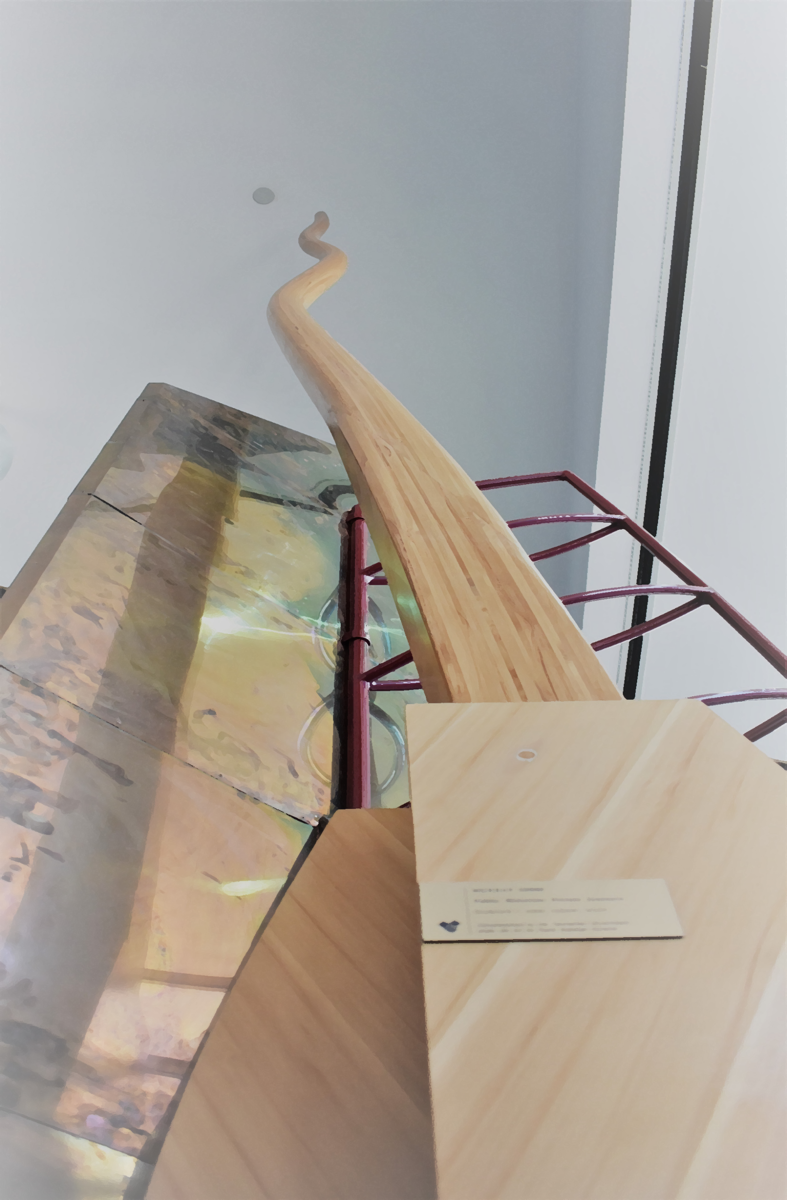

**Magistrates Court of Tasmania**

**Strategic Plan**

**2020 to 2023**

**Acknowledgement of Country**

In recognition of the deep history and culture of this island, the Magistrates Court acknowledges and pays its respect to the Tasmanian Aboriginal people, the past and present owners and custodians of this land - lutruwita - upon which we work and live.

**3**

**4**

**5**

**7**

**8**

**9**

**10**

**11**

**13-15**

**16**

**17**

**17**

**Acknowledgement of Country**

**Message from the Chief Magistrate**

**Vision, Values & Purpose**

**The Judiciary**

**Message from the Administrator of Courts**

**Intent of the Plan**

**Court at a Glance**

**Court Staff**

**Goals**

**Strategies**

**Chart**

**Feedback**

**Artwork Credits**

**Contents**

**Message from the**

**Chief Magistrate**

In developing our strategic plan we remain committed to our fundamental role in the community to provide access to justice that is independent, fair, impartial, and transparent. Underpinning how our Court operates is the principle of judicial independence. Each judicial officer has taken an oath to faithfully execute the office of magistrate and do equal right and justice to all persons to the best of their

their judgment and ability according to law.

The Court is continually striving to respond to a changing environment and we have developed a plan that will strengthen the Court’s ability to maintain high standards, which includes projects that will: see the implementation of new technology and practice procedures; enhance our role in the community; extend our judicial and staff professional development; and promote contemporary court facilities.

I thank my fellow magistrates for their insights and contributions and I thank Victor Stojcevski and Penelope Ikedife for leading and developing our plan.

I am also very grateful for the contributions of our dedicated and committed staff and the engagement of key external groups. The consultations and feedback have been instrumental in how we have shaped and focused our plan.

We look forward to meeting and embracing the challenges that lie ahead.

**CATHERINE GEASON**

**VISION**

***A Court that inspires confidence in justice.***

VALUES

PURPOSE

VISION

***A Court that inspires confidence in justice.***

* ***Independence***
* ***Integrity***
* ***Respect for all***
* ***Timeliness***
* ***Transparency***

***Protecting rights and upholding the law fairly and impartially.***

**VALUES**

* ***Independence***
* ***Integrity***
* ***Respect for all***
* ***Timeliness***
* ***Transparency***

**PURPOSE**

***Protecting rights and upholding the law fairly and impartially.***

**the judiciary**

The independence of the judiciary and courts are central to the way we operate. While the Court is organisationally placed within the Department of Justice (DoJ), each court operates independently of government and the executive. The Court works to ensure the independence of Tasmania’s judicial functions are preserved and maintained.

Appointed by the Governor, magistrates are part of the judiciary, impartial decision-makers in thepursuit of justice. Magistrates are supported by court staff.

The Court has formal channels for engaging with the parliament and executive government to seek their input into the administrative operations of the Court.

VALUES

PURPOSE

VISION

***A Court that inspires confidence in justice.***

* ***Independence***
* ***Integrity***
* ***Respect for all***
* ***Timeliness***
* ***Transparency***

***Protecting rights and upholding the law fairly and impartially.***

Parliament makes and

changes laws.

The executive government

puts law into action.

The judiciary interprets

and applies the law.

**Message from the Administrator of Courts**

walks of life, and how committed our staff are to pursuing the vision of inspiring confidence in justice.

Our plan serves to remind the public and Government of the critical role played by an independent Court. As part of the planning process, we consulted with fourteen different external groups across Tasmania and with over ninety per cent of staff. The consultation generated two major themes: the Court is highly respected and doing well, but there are things we, the Court administration, can do better. Our strategic plan builds upon those two themes.

In supporting the judicial function of the Court, the operational arm of the Court will continue to:

* focus on putting people who interact with the Court at the centre of our service delivery;
* plan for and respond to changing demand; and
* develop and build the expertise and professionalism of our people.

As the Court’s responses to the evolving technology and changing expectations of the people who interact with the Court during the current pandemic demonstrate, the Court is continuously faced with the challenge of providing new and improved services that help to protect rights and uphold the law in an imperfect environment.

Finally, I take this opportunity to thank staff and other colleagues for helping to develop and implement this plan. We look forward to making the 2020 to 23 Strategic Plan a success.

Our strategic planning process started before the onset of the COVID-19 pandemic and concluded after the serious effects of the pandemic stretched across the State and the nation. Undertaking a strategic planning exercise in the middle of a pandemic confirmed how critically important the role of this Court is to the Tasmanian community, how it is relied upon by people from all

**PENELOPE IKEDIFE**

**INTENT OF THE PLAN**

This Strategic Plan provides an opportunity for the Court to think deeply and act positively about how it can evolve to meet future needs.

It also looks at how the Court can maximise the public value delivered by its operations. In developing this plan, the focus was to ensure that the Court continues to offer accessible and high-quality justice and conflict resolution services to all people who interact with the Court. It addresses some known challenges, such as the implementation of new technology in the Court and the implementation of new modern summary court legislation. It also seeks to tackle and respond to the changing expectations of people who come to the Court.

The Court will adapt continuously to changing demands and expectations, and seize opportunities to improve.

**COURT AT A GLANCE**

The Magistrates Court of Tasmania is a court of record created by section 3A of the *Magistrates Court Act 1987*. It is made up of the Chief Magistrate, the Deputy Chief Magistrate, and Magistrates. Magistrates have jurisdiction to hear and determine a broad range of legal matters.

The administrative arm of the Court, constituted by approximately sixty staff who work in operations and management, supports the judiciary to provide all Tasmanians with direct and timely access to justice.

Legislation provides for the various jurisdictions of the Court to be divided into divisions. These divisions are the:

* Criminal & General Division
* Youth Justice Division
* Coronial Division
* Administrative Appeals Division
* Civil Division
* Children’s Division
* Mining Division.

The Court works from a network of courthouses across 11 locations in metropolitan and rural areas of Tasmania.

The independence of the Magistrates Court is central to maintaining public trust and confidence in the justice system. Judicial independence guarantees the right of each Tasmanian to a fair and public hearing by a competent, independent and impartial Court established by law.

Increasing and sustained demand for Court services in recent years is causing significant workload pressures for the judiciary and registry staff. More cases each with more charges in a complex legislative environment are creating challenges for the criminal justice system. At the same time, issues in the civil jurisdiction are becoming more complex and taking longer to resolve. The number of “reportable” deaths being investigated by coroners in Tasmania is also increasing, with added weight being given to the death prevention role of coroners. As such, Tasmania’s summary criminal and civil, and coronial justice systems, need to adapt to ensure that each matter takes the most appropriate, timely and effective path through the legal setting.

The Magistrates Court’s success is driven by a dedicated and talented workforce, who make up the administrative side of the Court. The Court’s staff are employed by the Department of Justice (DoJ) but some also perform statutory functions as officers of the court.

Court staff deliver a range of justice services that support and underpin independent judicial decision-making. These services are people-focused and contribute to the delivery of fair, timely, accessible and high-quality justice for all Tasmanians.

The *DoJ People Strategy 2020 to 2025* sets the directions DoJ will focus on to improve the working conditions and workplaces of its staff. The People Strategy will assist to empower Court staff, so that the Court can perform at its best.

**Court Staff**

***Integrity***

***Respect for all***

***Timeliness***

***Transparency***

***Independence***



**GOALS**

1. Improved access to justice.

2. High quality justice and court administration.

3. Enhanced role of the Court in the community.

4. Strengthened capabilities and improved wellbeing of magistrates and staff.

5. A modern, accessible and safe Court.

***A Court that inspires confidence in justice***

***Protecting rights and upholding the law fairly and impartially***

**STRATEGIES**

The following Strategies support the Court’s Vision and are informed by the Court’s Values. The Strategies will help the Court achieve its Goals, subject to appropriate resourcing.

**Goal 1 – Improved access to justice**

* Implement new Magistrates Court (Criminal and General Division) legislation, and associated policies and procedures.
* Increase online information services and improve communication.
* Implement the national framework for family violence information-sharing between the Court and federal Family Law Courts.
* Develop a coordinated approach to reduce case backlog.

**Goal 2 – High quality justice and court administration**

* Implement Justice Connect, while improving ICT security and capability and delivering a technology upgrade program.
* Improve the efficiency and effectiveness of Court processes to reduce complexity, and the time and cost to people who interact with the Court.
* Work with other justice agencies to streamline system-wide processes.
* Continue to increase use of video and audio conferencing.
* Pursue satisfactory and sustainable funding for the Court in all its operations and jurisdictions.
* Implement simple feedback/complaints mechanisms for people who interact with the Court.
* Provide improved support services to self-represented litigants.

**Goal 3 – Enhanced role of the Court in the community**

* Expand sentencing workshops and court tours, particularly targeting schools and vulnerable communities.
* Explore the use of social media and other digital channels to engage with the community and build understanding of the Court’s work.

**Goal 4 – Strengthened capabilities and improved wellbeing of**

**magistrates and staff**

* Undertake cultural competence training for magistrates that highlight Equality before the Law Bench Books.
* Extend judicial and staff professional development.
* Increase and evaluate judicial and staff wellbeing programs.
* Embed the DoJ *People Strategy 2020 to 2025* across Court staff, building staff resilience and preparedness for change.
* Attract, recruit and retain employees from diverse groups in the community, and build the capacity of the workforce by providing awareness, education and training around diversity and inclusion.

**Goal 5 - A modern, accessible and safe Court**

* Promote new generation facilities in Burnie and Launceston that are consistent with contemporary Court standards.
* Provide a modern and flexible digital Court environment that helps the public while supporting organisational productivity.
* Implement risk management and business continuity plans and practices that address the COVID-19 pandemic.



**Strategic Plan 2020 to 2023**

**Independence | Integrity | Respect for all | Timeliness | Transparency**

A Court that inspires confidence injustice.

**Vision**

**Purpose**

**Goal 1**

Improved access to justice.

**Goal 2**

High quality justice and court administration.

**Goal 3**

Enhanced role of the Court in the community.

**Goals**

Protecting rights and upholding the law fairly and impartially.

**Goal 4**

Strengthened capabilities and improved wellbeing of magistrates and staff.

**Goal 5**

A modern, accessible and safe Court.

**Goals**

**Purpose**

**Feedback**

Every person in contact with the Magistrates Court should expect to receive respectful, accurate and timely services. We want to hear from you if our service has exceeded your expectations or is not what you expected.

Please email your feedback to: [registry.hobart@justice.gov.au](mailto:registry.hobart@justice.tas.gov.au?subject=Strategic%20Plan%20Feedback)

Or write to: Administrator of Courts

Magistrates Court

GPO Box 354

Hobart TAS 7000

**Artwork Credits**

Front Cover – Murray Gibbs, *Public Histories Private Journeys*, Hobart

Magistrates Court

Page 1 – Sara Lindsay, *untitled* (1995), Hobart Magistrates Court

Page 4 – Kit (Christine) Hiller, *Flaming Robin*,Devonport Magistrates Court

Page 8, 11, 13 – Sara Lindsay, *untitled* (1995), Hobart Magistrates Court

Page 9 – Kit (Christine) Hiller, *Crested Tern*,Devonport Magistrates Court

Page 18 – Kit (Christine) Hiller, *Pied Oystercatcher*, Devonport Magistrates Court

**Magistrates Court of Tasmania**

Burnie

38 Alexander Street

Devonport

8 Griffith Street

Hobart

23 – 25 Liverpool Street

Launceston

73 – 76 Charles Street

[www.magistratescourt.tas.gov.au](https://www.magistratescourt.tas.gov.au/)

**ADDRESS**